SPSU

2014

Music Store User Guide

Team: Breaking Code

Mohil Patel

Chaeson Smith

Tyler Scoville

Nathanael Thompson

CS 3693 Applications Programming

Table of Contents

Login Screen 2

Forgot Password 2

Employee Dashboard 4

Employee Dashboard – Administrator Account 4

Employee Dashboard – Normal Account 4

Search Module 6

# Login Screen

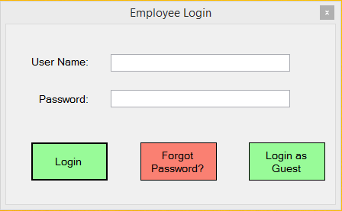

Figure 1 - Login Screen

In order to login in to Music Store system, proper username should be entered in the input field “User Name”, and password in the “Password” input field. After typing username and password, press “Login” button in order to proceed to the next screen of the system where user would be able to see inventory search, checkout, managing inventory, and reports with administrator account. User with normal account would be able to use 2 out of 4 modules for the system. Normal user would have an access to Look for more details in Employee Dashboard section.

In order to retrieve the password, user should type their username in the “User Name” input field. And then press “Forgot Password?” button to proceed to the next screen for password retrieval. Look at forgot password section to get more details on retrieving the account password.

User can also login as a guest by clicking on “Login as Guest” button. After pressing that button, system will proceed to the next screen where user would be able to search for the inventory from music store database. See for search module section for more details on using inventory search.

# Forgot Password

In login screen, user must type their username in “User Name” input field. After entering username, click on “Forgot Password?” button.

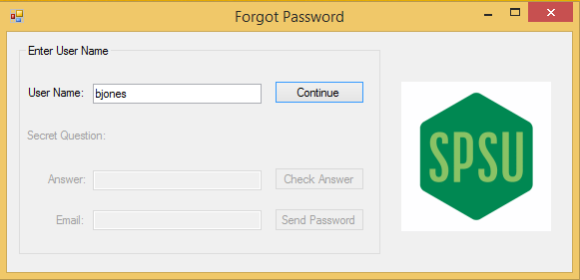

Figure 2 - Forgot Password Screen

In forgot password screen, if the username typed in the “User Name” input field is correct, press “Continue” button to display “Secret Question”, and to enable “Answer” input field.

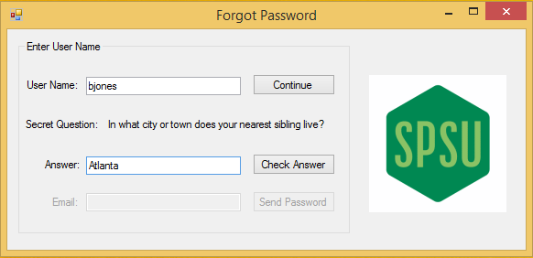

Figure 3 - Forgot Password Screen - Secret Question

After clicking on continue, it will display secret question and enables answer input field. As shown in figure 3, enter the secret question answer, and click on “Check Answer” button. It will enable the email input field which will send password to the entered email. Once the correct email is entered in Email input field, click on “Send Password” button. It will send account password to the email.

# Employee Dashboard

In this section, user would get familiarize with navigating from different modules mentioned above in the login screen section. There are two types account which would have an access to Employee Dashboard. Two types of accounts are administrator account, and normal employee account.

## Employee Dashboard – Administrator Account

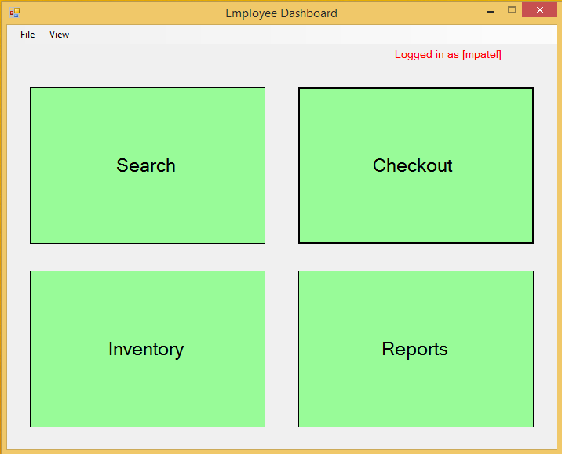

Figure 4 - Employee Dashboard with Administrator account

As show in figure 4, Employee Dashboard composed of 4 different modules. Each module can be used by user with admin account. Admin used would be able to click on all four modules. In order to get more details on each module, see their respective section in this user guide.

## Employee Dashboard – Normal Account

In this section, normal account would have an access to two options for navigating to different modules. See figure 5 for a picture of Employee Dashboard for normal account. In order to get more details on the each individual module, see their respective section in this user guide.

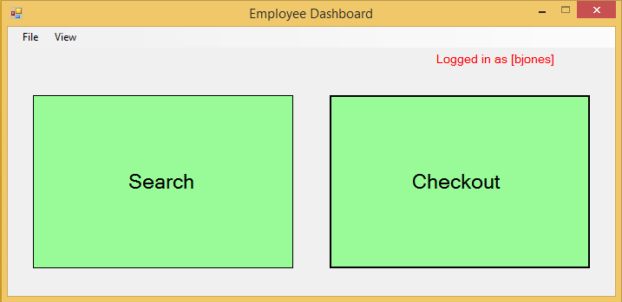

Figure 5 - Employee Dashboard for Normal Account

# Search Module

In this module, user would be able to search inventory using various different search options. User will be able to search database by Artists, Albums, Genres, Orders, Customers, and Employees. See figure 6 to see on various search option. In order to search database by type, click on one of the Search For radio button, and then click “Search” button. User can also search by typing keywords in “Search Term” input field.

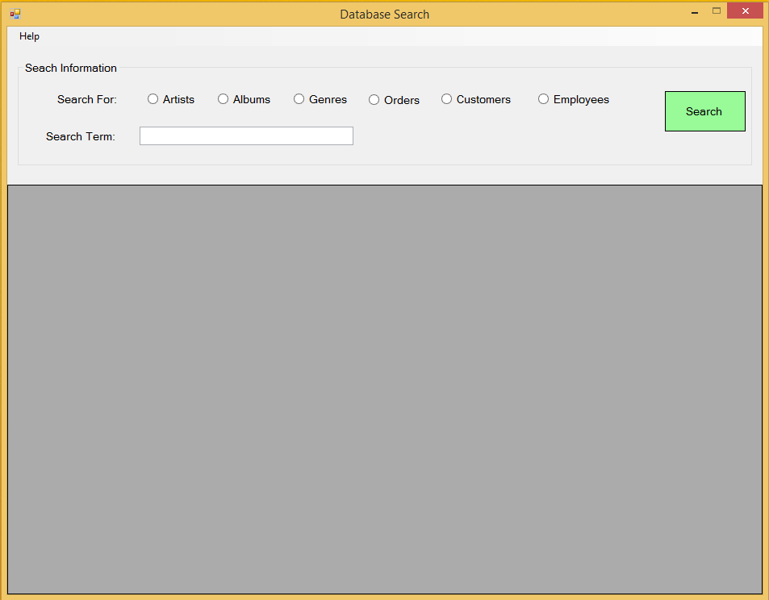

Figure 6 - Search Module

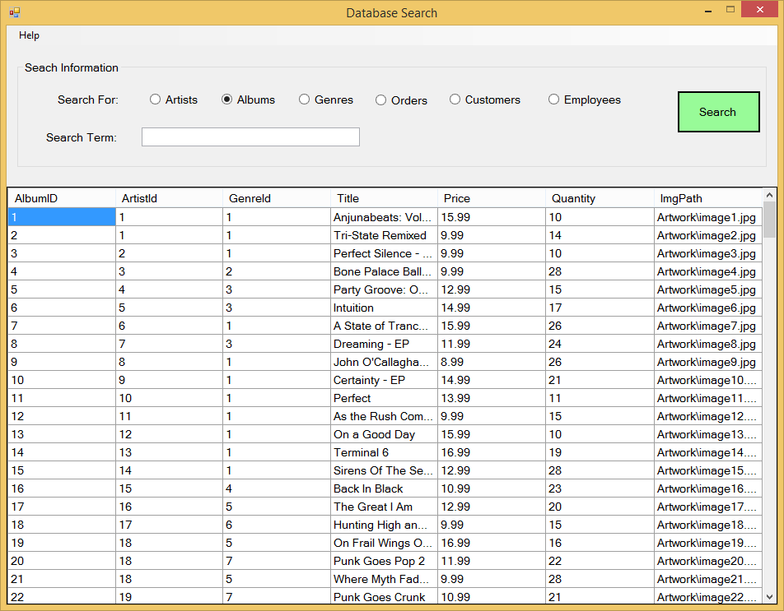

Figure 7 - Search Module - Search By Albums

# Checkout Module

In this module, user would be able to checkout customers with music albums. User can look up customer by clicking on “Customer Lookup” button. User can also add customer information to the database by click on “Add Customer” button.

After looking up customer, user would be able to checkout items in the inventory. See figure 9 to see the cart system, and checkout process.

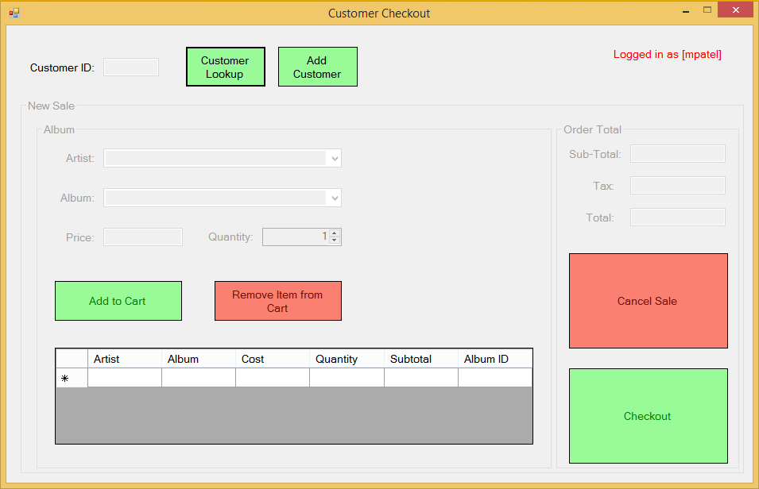

Figure 8 - Customer Checkout Screen